OOP Project

# Related image**Project Implementation Report: Iteration 1**

CS 319 Object Oriented Software Engineering  
Eray TÜZÜN  
Group 1-I: Private Moon Inc.

Project Group Members

• Doğa Oruç – 21602022

• Çağrı Orhan - 21503102

• Fazilet Simge Er - 21602358

• Kaan Ünlü - 21602622

• Ege Turan – 21502441

Contents

**Project Implementation Report: Iteration 1** 1

1.0 Introduction 3

2.0 Design Changes 3

3.0 Lessons Learnt 4

4.0 User’s Guide 5

4.1 System Requirements & Installation 5

5.0 Glossary & references 5

# 1.0 Introduction

# 2.0 Design Changes

When we first started to design our classes we came up with following class diagram:

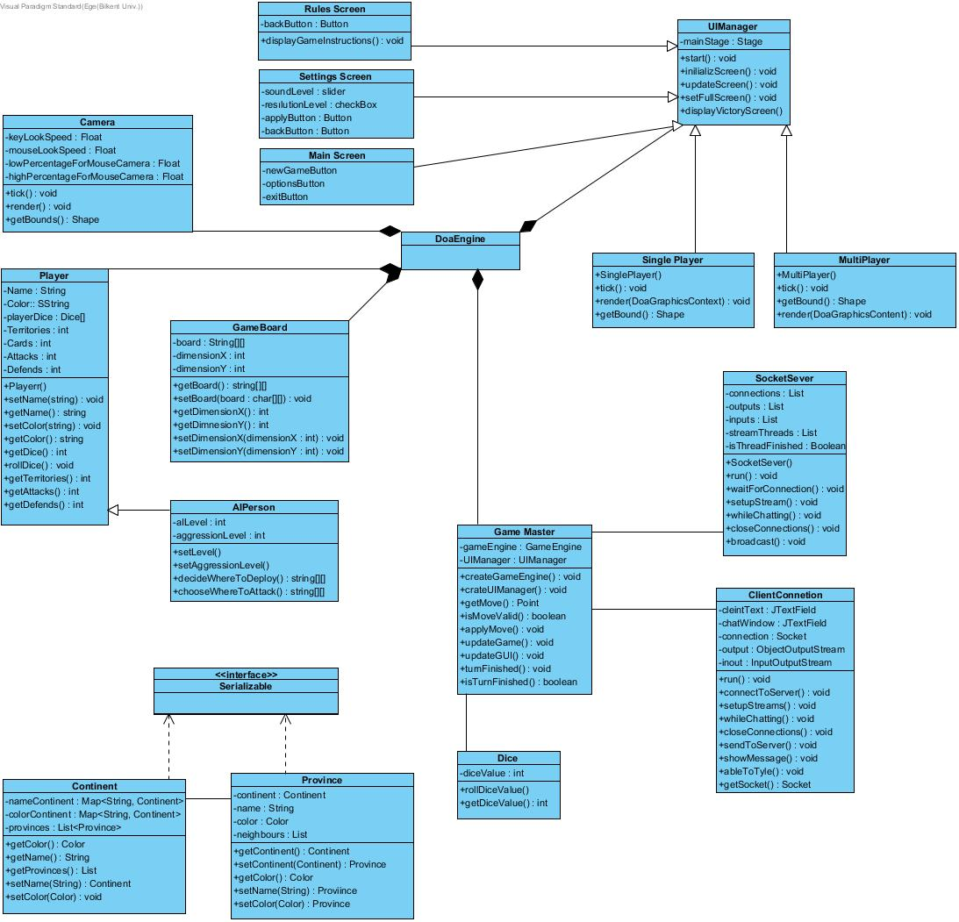

##### Figure 2.1 Class diagram at the time of the first iteration analysis document

As time went on and we fleshed out our design more, we changed and added some classes and added Exception classes. All of the exception classes use inheritance and handle one of the problems that we faced during the development process.

Secondly, we added the new MessageType and Message classes to improve communication and data transfer more efficiently.

Thirdly, we added ProvinceHitArea to determine the vertices of the province. ProvinceHitArea takes provinces and with the read vertex values, it determines the physical span of that province.

Our class system is on the development process and project is still changing as this is still the first iteration. After we complete the first iteration process we will a give more detailed and developed class diagram and we will make more understandable explanations for the change we made.

This is our updated class diagram for now:

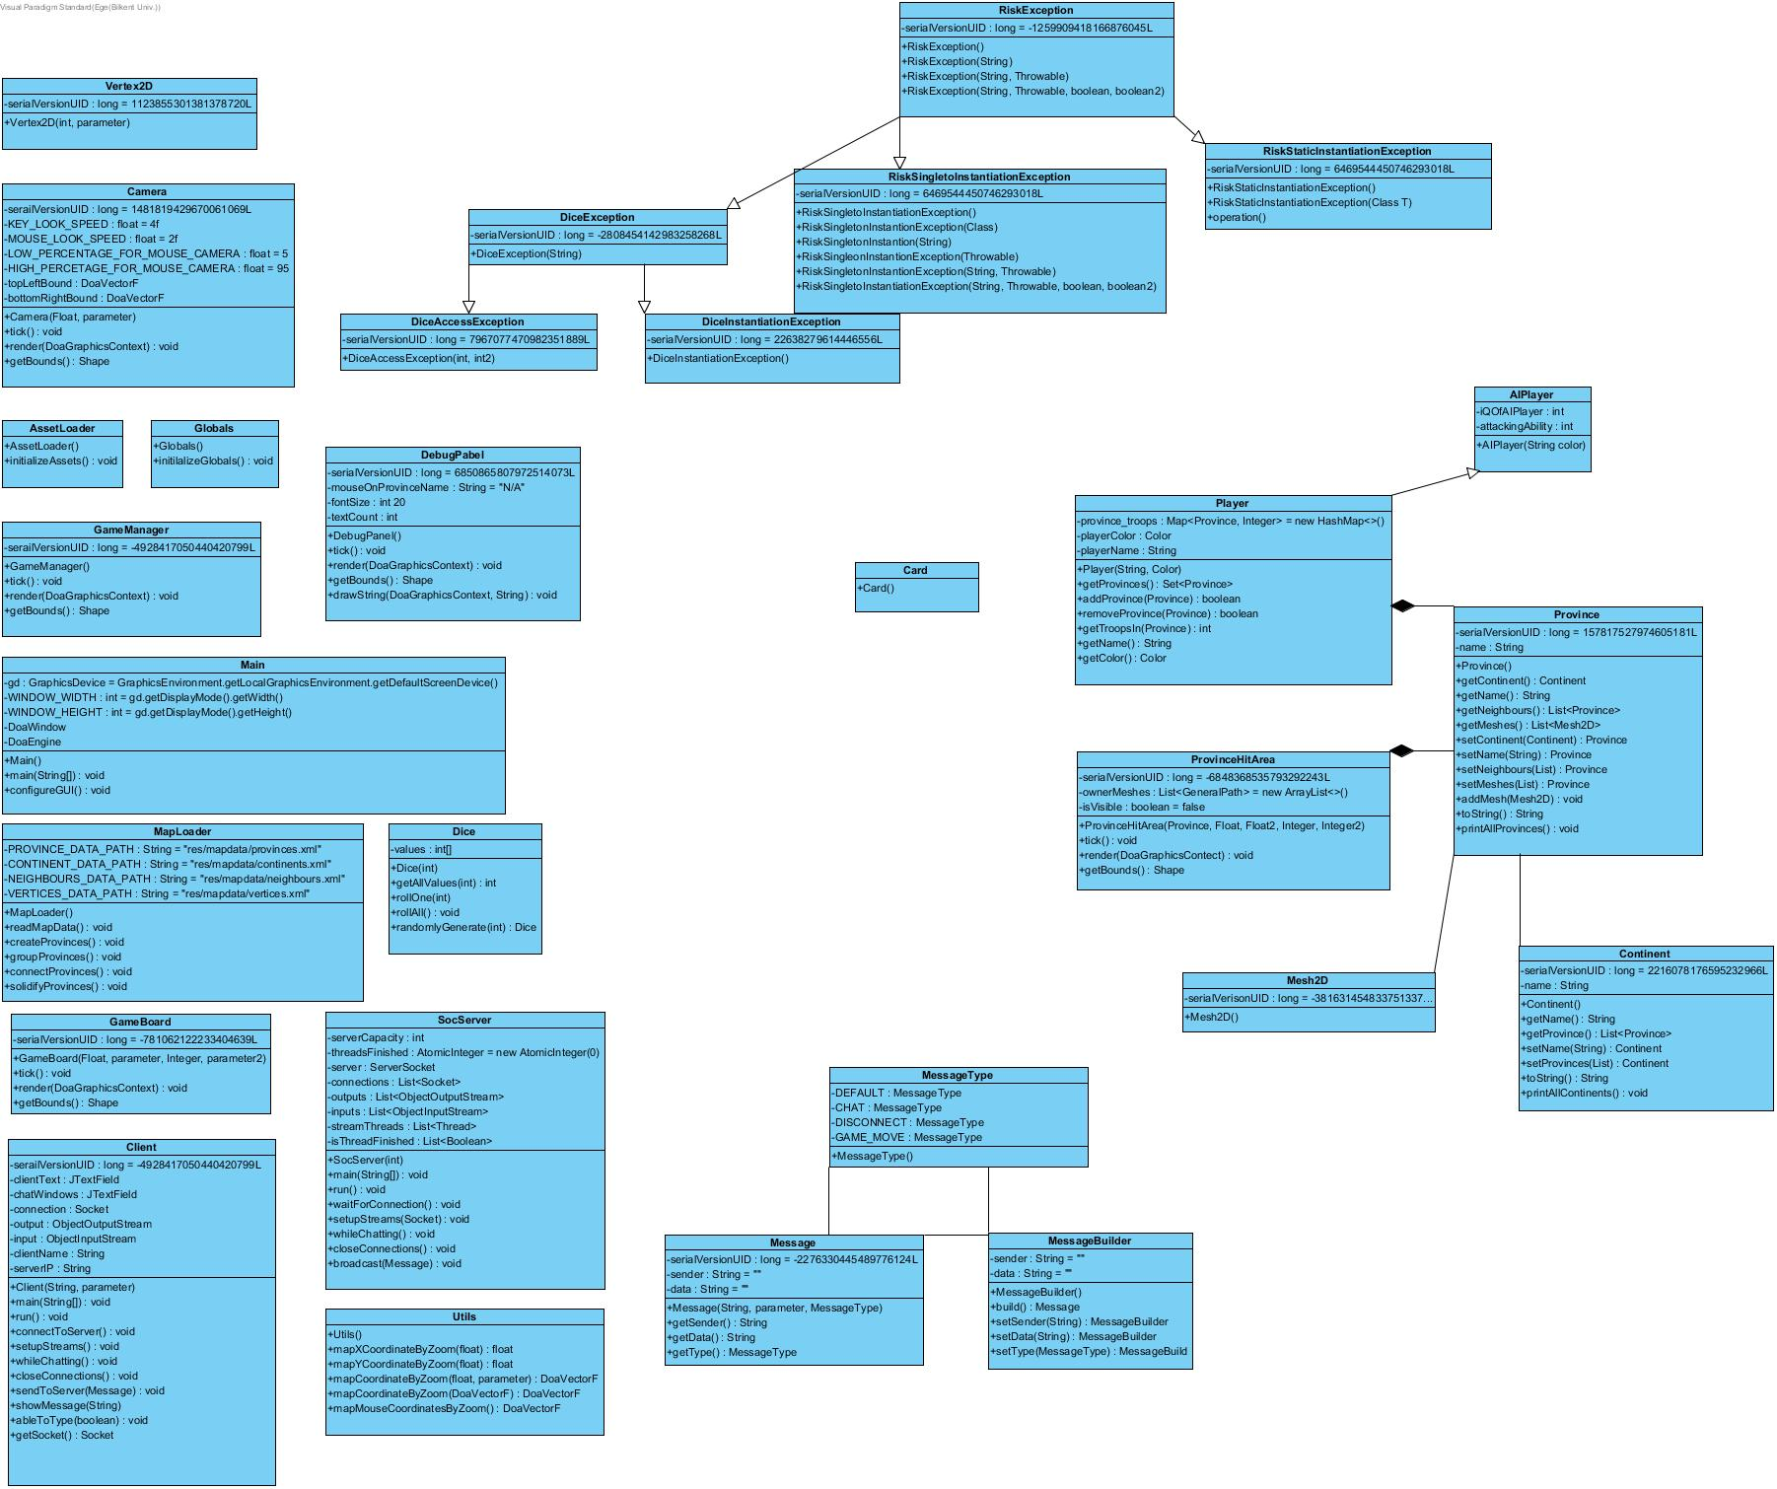

##### Figure 2.2 Class diagram at the time of the first iteration design document

# 3.0 Lessons Learnt

3.0 Lesson Learned

We encountered a lot of problems while implementing and designing this project. The first important issue was about a lack of communication. As a group, we were meeting only 2 times a week. This allowed occurring disruptions in the project due to lack of sufficient communication. There were problems while bringing the parts of the project together. We decided to meet more often because it was obvious that something was going wrong. We've increased our group meetings’ frequency. Also, we have started to use the “Discord” app which is supplying free voice chat and screen sharing. We saw that more and instant communication can solve many problems. We started to do our jobs with better synchronization and faster. The solution process gained speed through communication.

Another issue was about disagreements. As is known, the Risk is a board game and there is no single official version of the game [1]. Designing the game on a digital platform required many decisions about graphics and mechanics. At some points, we had difficulties in the decision-making process. When deciding on the mechanics and graphics of the game different ideas were raised. Our solution was making assessments and trying to find out which one would look and feel the most impressive with the least amount of work, so that our final product would be as complete as it could be (and hopefully with the most extra features) by the final deadline. We were meeting at a common point after long reviews. This really helped us to maintain the decision-making process.

Another compromise example occurred because different group members are using different coding styles (such as how everyone placed their curly parentheses). When merging different individual’s codes into the same project, it was hard to read and write. We decided to choose the coding style by voting. Decisions were determined by the votes of the members of the group so that no one would resist the decisions. This provided a democratic solution to the discussions. We had set a consistent coding style that everyone will follow. This aims to increase the maintainability of the code.

We also realized the psychological effect of working as a group. The bystander effect occurs when the presence of others discourages an individual from intervening in an emergency situation. When an emergency situation occurs, everyone has a tendency to put the responsibility on someone else. We encountered with bystander effect so much on the beginning of the project. Work distribution in advance of deadlines helped us solve this problem.

All in all, starting to work with a group can lead to many problems inside the group. We learned that a problem within the group can only be solved by within a group. We saw that synchronous communication, compromise, reviews, and brainstorming is essential tools for managing a group project.

# 4.0 User’s Guide

## 4.1 System Requirements & Installation

# 5.0 Glossary & references

|  |  |
| --- | --- |
| [1] | Brilliant Maps, “27 Best Risk Board Game Versions Based On Real Player Reviews,” 28 August 2016. [Online]. Available: https://brilliantmaps.com/risk/. [Accessed 31 March 2019]. |